- Convert the ERD shown in Figure 2 into tables. This ERD is identical to problem 1 except for the use of an associative entity type instead of the M-N relationship. You only need to indicate the conversion rules and table design for the associative entity type.
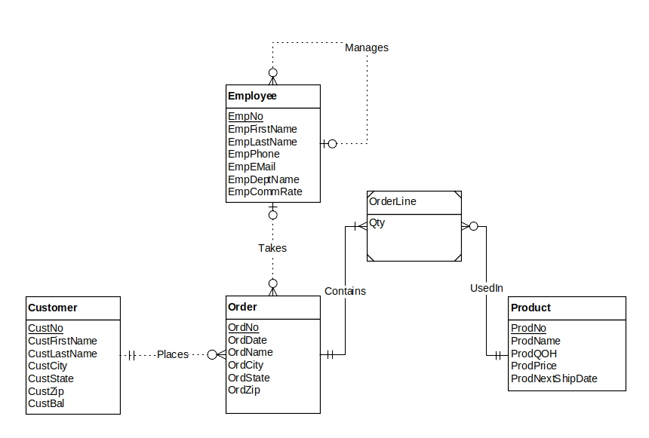 Figure 2: ERD for Problem 2

Solutions:

The only difference in the solution for problem 2 from problem 1 is the usage of the identification dependency rule in problem 2 versus the M-N relationship rule in problem 1.

Result after conversion
Customer(CustNo, CustFirstName, CustLastName, CustCity, CustState, CustZip, CustBal)

Employee(EmpNo, supempno, EmpFirstName, EmpLastName, EmpPhone, EmpEmail, EmpDeptName, EmpCommRate)
FOREIGN KEY(supempno) REFERENCES Employee

Product(ProdNo, ProdName, ProdQOH, ProdPrice, ProdNextShipDate)

Order(OrdNo, CustNo, EmpNo, OrdDate, OrdName, OrdCity, OrdZip)
FOREIGN KEY(custno) REFERENCES customer
FOREIGN KEY(empno) REFERENCES employee
CustNo NOT NULL

OrderLine(OrdNo, ProdNo, Qty)
FOREIGN KEY(ordno) REFERENCES order
FOREIGN KEY(prodno) REFERENCES product

Conversion rules
- Use the entity type rule to convert each entity type
- Use the 1-M relationship rule for all relationships
- Use the identification dependency rule to add two components (OrdNo and ProdNo) to the primary key of the OrderLine table

